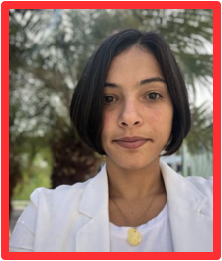
Dr. Jehyra M. Asencio Yace joined AmeriCorps in 2020 as a Portfolio Manager in the Mid-Atlantic Region. She completed her PhD in Interdisciplinary Social Sciences at the University of Brasilia and was a Research Fellow at the Brazilian Institute for Racial and Ethnic Inclusion. Beyond academia, she has worked and volunteered with non-profits in the areas of environmental stewardship, disaster preparedness and social justice which has made her a passionate advocate for resilient organizational capacity building. Jehyra manages several research and evidence building projects within ORE, some through the formal role of a Contracting Officer Representative (COR). She lives in Cabo Rojo, Puerto Rico with her husband and a hilarious rescue Pitbull named “Boogie”. After work you can find her camping in the rainforest, cooking plant-based meals, swimming in calm Caribbean waters or volunteering. Her perfect sandwich is made of “casabe toast” (made with cassava flour), thick avocado slices, tomatoes, olive oil, sea salt and Aleppo pepper.

